Programming Assignment #
Name: Amna Malik ID: 11827604

Problem-1
____________________________________________________
(Your Codes)
public class AmnaMalik
{
public static void main(String[] args) {
System.out.println("My name is Amna Malik and my R Number is R11827604!");
}
}
- - - - - - - - - - - - - - - - - - - - - -
(Output- screenshots)
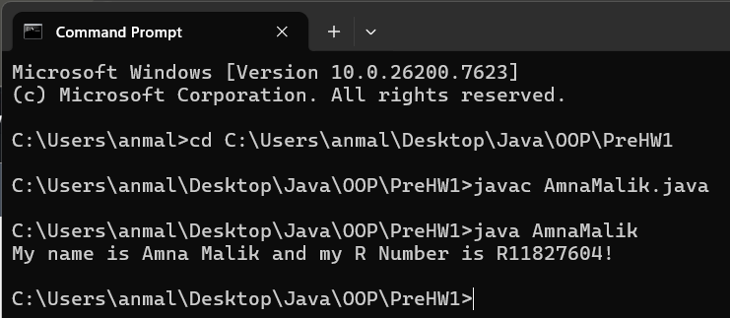
Problem-2
____________________________________________________
(Your Codes)
public class AmnaMalikIntelliJ {
public static void main(String[] args)
{
System.out.println("My name is Amna Malik and my R number is R11827604!. I installed IntelliJ IDE");
}
}
- - - - - - - - - - - - - - - - - - - - - -

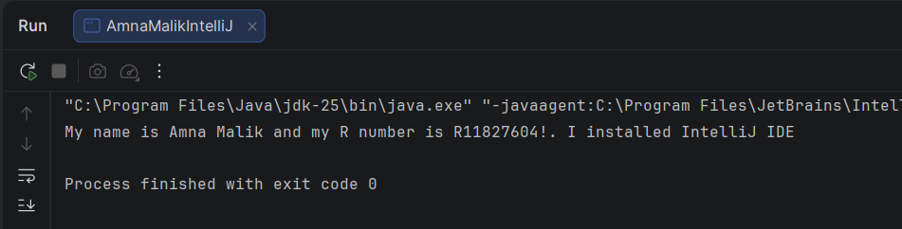
(Output-screenshots)

